Update from Mutare 

Larry and Jane Kies
Africa University, P.O. Box 1320
Mutare, Zimbabwe

Newsletter
Vol.34 No.3
August, 2020

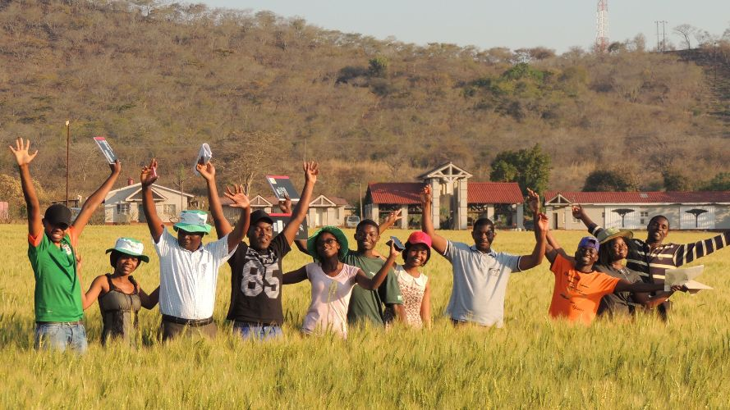
"I have appeared ...to appoint you as a servant and as a witness of what you have seen of me and what i will show you." Acts:26:16

Dear friends and family,
Greetings from Zimbabwe, where along with most of the world the disruptions caused by covid-19 continue.
We are slowly emerging from winter, circles of wheat are being irrigated on the AU farm, and students and staff are preparing for online lessons for this coming semester. Campus has been in partial lock down since March, and it has been quiet. About 150 students have remained in their dormitories due to travel restrictions within Africa, and have been engaged in Vacation Relief Work.
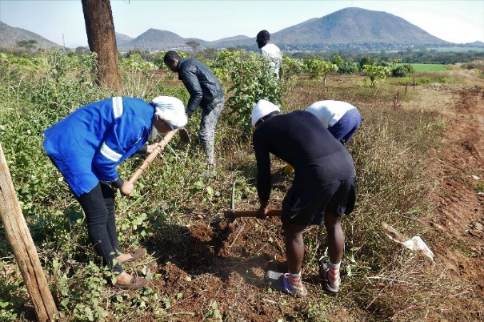 | 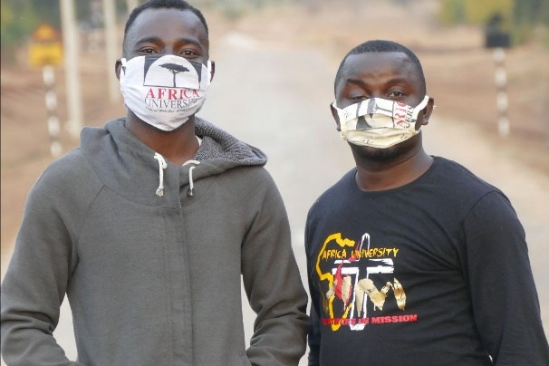
Vacation Relief Work- Students Clearing Invasive Bee Bush and Lantana on Campus | Nigerian Students Caleb and Dan Exercising at the end of the day.

How Can We Connect?
Since we are not able to visit you in person this year, we would love to ‘visit’ you online! We have so much to share with you as we show you how God continues to work in and through Africa University.
We have a number of options to suggest to you, whether you are meeting online as a church, a UMW group or prayer group, or not meeting at all:
- We can send you a 5-minute video that was made last year that gives an overview of our roles as GBGM missionaries at Africa University.
- We can send a recording of a 19-minute video presentation for you to use in whatever way seems best.
- We would be delighted to meet you in an online church service, or meet online with a group for 5 minutes, 20 minutes or 30 minutes.
For online meetings with us, the dates that we are available are:
August 17-31
September 1 -30
October 1-31
Should you wish to organise a meeting, or if you would like a recorded presentation, please email LKies@africau.edu and jkies60@gmail.com .

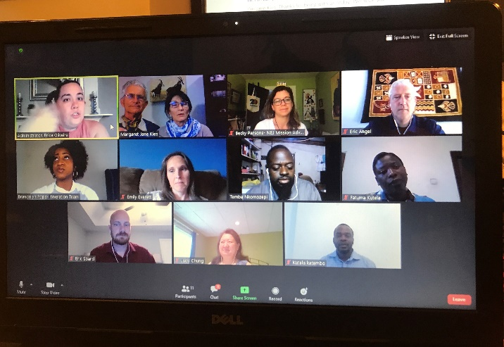
Zooming.

Keeping Connected to Students
I would love to share with you this experience of one of our former Intensive English students.

The Faith of a Present Day Daniel
I come from Cote d’Ivoire. My father has eight children and two wives. I grew up without knowing who my father was, and without a name, until my father finally got me a birth certificate. When I was eight years old, my grandparents sacrificed to pay for my schooling.
Seeing the poverty and suffering of my family and other people made me feel so helpless. I asked GOD to make me rich, or enable me to become a pastor so that I could make a difference. So, I put all my hope and efforts into completing my studies.
The United Methodist Church of Cote d’Ivoire holds an annual national competition for those who have a calling to become pastors. Because of my high grades, I was selected by my conference in 2018 to study at Africa University under scholarship. That is the grace of the Living God!
Africa University has changed my life in many ways, and I can say all my burdens and fears have disappeared. Unbelievable! I have food to eat; I am able to go to hospital when I am sick; I have books. My dream to help the people of my country has been strengthened; I have faith that Africa University will equip with the knowledge and competence I need to fulfil my calling.
May God bless the supporters of A.U. students.

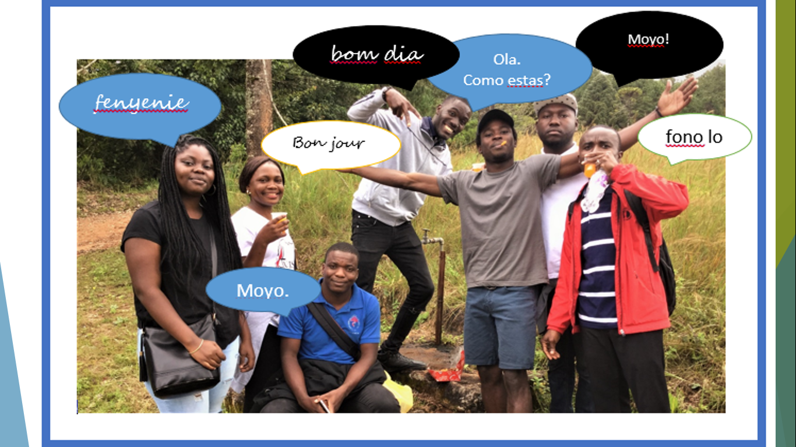
Intensive English Students

Farm News
Mr Mupofu, the Farm Manager, and his team have made sure that the AU Farm continues producing despite the restrictions caused by covid-19. A bumper crop of wheat, including two circles under the center pivot, is now flowering. Plans are underway to finish lining the fish ponds and stocking them with tilapia fingerlings. A target of fundraising is a new 4-tonne truck for collecting inputs and marketing produce. A successful crop of cabbages means a lot of truckloads!

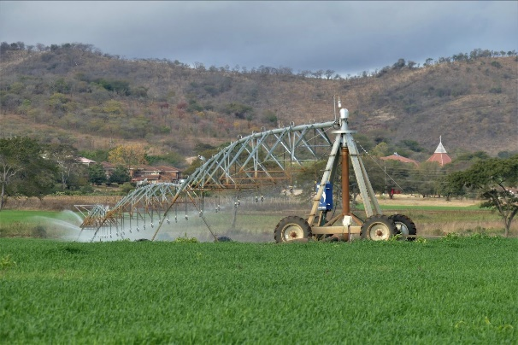
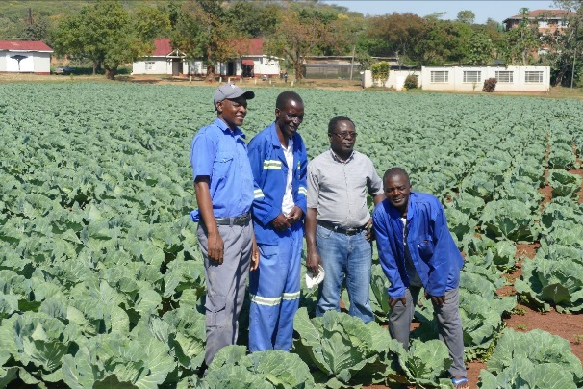

Family News
We are thankful for the health of our children. One 'Covid 19 Lockdown' highlight has been playing board and card games online as a family!
- Michael has completed a summer internship in Ames, and will begin his third year of study at Iowa State with online classes except for French.
- Carly recently drove 5300 km on an exploration of the varied landscape of Queensland! The new semester has brought students back to the student ministry centre, The Garden.
- Pule and Christine continue to build their lives and new home in Colorado.
- Ben works from home in Brooklyn, but enjoys hiking upstate with Ada on weekends.

How You Can Pray With Us
Please pray for:
-a smooth opening of the semester as students and staff alike transition to online teaching and learning.
-protection for Zimbabwe as a nation as it faces Covid-19 cases increasing despite a partial lockdown.
-missionaries carrying out online itineration

Larry- I will be retiring from GBGM at the end of September, but of course the Farm will continue. Jane will continue as a missionary at Africa University, and I will be involved in teaching Agriculture students on a voluntary basis. Please continue your support of Africa University and of Jane in her teaching.

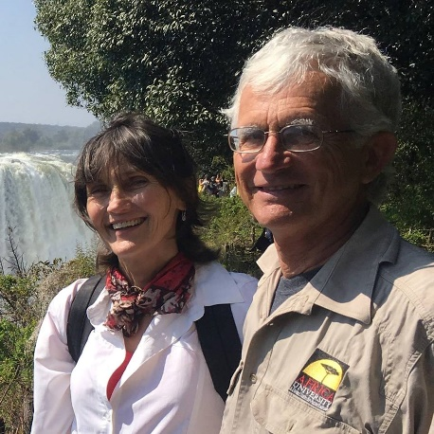
How Can You be Involved
Prayer Support
Give through the Advance Special:
https://advance.umcmission.org/
Jane 10739Z
Larry 09572Z
Farm Development 3021028
Scholarship Fund 3021027
Check our website:
https://larrykies.wordpress.com/
Check the Africa University Websites:
http://www.africau.edu/
https://www.support-africauniversity.org/
Join our newsletter list:
LKies@africau.edu or JKies60@gmail.com
Follow the AU Farm Facebook page:
https://www.facebook.com/au.farm.37/posts/577770063106570

THANK YOU!

We are grateful for your faithful support and care over the years. Africa University is nurturing young men and women who will be among the future leaders and decision makers in the continent of Africa. Your partnership is helping to mold them into Christ-centered leaders in the church, education, agriculture, business, health and government.
Larry and Jane Kies

Mail service to and from Zimbabwe at the moment is a bit erratic. Many people have told us that their snail-mail letters to us were returned as "Undeliverable". We are still here!! Please use email if possible to communicate with us. Thanks!!

